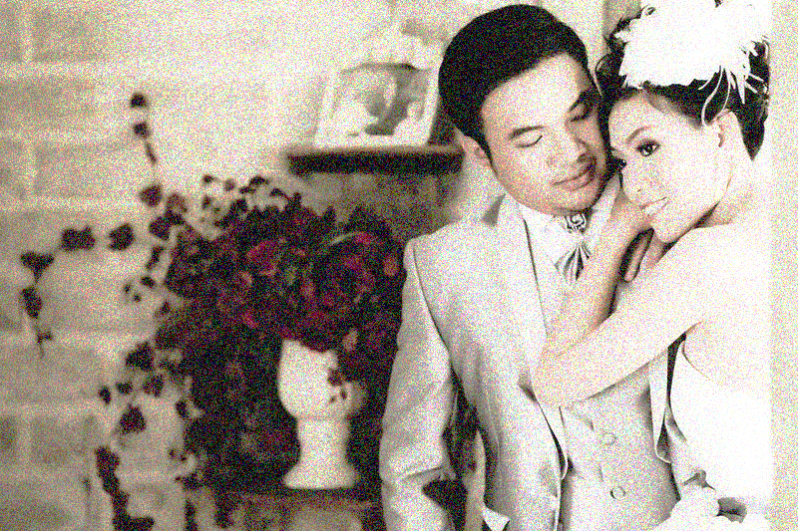“I originally approached Pixelford Photography to shoot engagement photos for me and my wife. Simon and Rupert sat down with us to discuss our every want and need. When the day of the shoot finally came, every detail was immaculately prepared. When we arrived at our location, there was a canopy and chair for us to rest under, out of the sun, during scene and lighting changes. My wife cried such happy tears on the day we first saw our wedding photos. They were so vivid, it felt like we were back in the moment. We highly recommend the personable and talented Pixelford photographers for capturing anyone’s wedding day!



*Jerry and Karen Day*



Pixelford Photography offers a wide range of services from personal to commercial. Learn more about the services we offer below, get to know our process and our pricing models, and contact us to get started!

Favorite

### **Wedding portraits**

We’ve captured portraits for over 600 wedding couples and their families. Our team of photographers, led by Simon Pixelford, knows what it takes to masterfully capture the beauty and emotions of your wedding – resulting in treasured memories that last a lifetime. We’ve photographed weddings all around the world for everyday, wonderful people, as well as high profile celebrities. From covering a parachute-jumping ceremony to an African safari wedding to the more traditional wedding – we literally have done it all.

### **Wedding event photography**

Why stop shooting after the portraits and ceremony are over, when our photographers can capture the celebration of music, dancing, karaoke, or whatever you have planned for your special day? We send out a larger, or second, photography crew to shoot documentary-style images the whole night through. Capture Aunt Jane doing the Macarena, Cousin Augustus playing fiddle in the band, and your friends’ laughter and cheer, to remind you of the impact your wedding had on everyone.

## **Studio and location portraits including:**